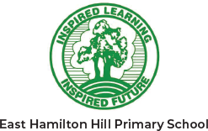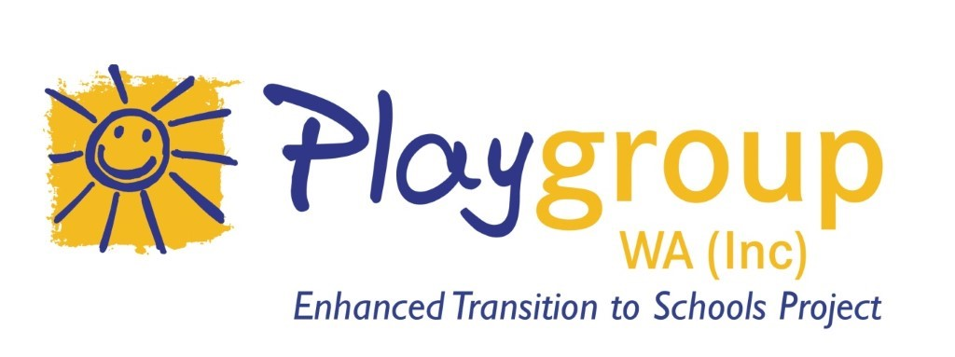

At playgroup you can have fun playing with your child, meet other parents and familiarise your child with the school environment ready for future school years.

Playgroup at East Hamilton Hill PS is a family-run playgroup for children 0-4 years and their parent/caregiver. Come along for a **free** trial for coffee and some fun!

For more Information and to register your interest please contact: EastHamiltonHill.PS@education.wa.edu.au

lease email: penrhosfamilypg@outlook.com

**WHEN:** Mondays

**TIME:** 9:00-10:30

**WHERE:** East Hamilton Hill Primary School - Parent Room

**BRING:** hat, water bottle, your own child's morning tea

PLAYGROUP WA INVITES YOU TO THE NEW

**East Hamilton Hill PS**

**Family**

**Playgroup**